**पश्चिम क्षेत्र की**

**{{month_name}} माह की**

**प्रणाली प्रचालन रिपोर्ट**

System Operation Report of Western Region

For the month of

**{{month_name}}**



पावर सिस्टम ऑपरेशन कारपोरेशन लिमिटेड

**(भारत सरकार का उद्यम)**

पश्चिम क्षेत्रिय भार प्रेषण केन्द्र**,**मुम्बई

**Power System Operation Corporation Ltd.**

**(A Government of India Enterprise)**

**Western Regional Load Despatch Centre, Mumbai**

|  |  |  |
| --- | --- | --- |
|  | | **पृष्टसूची CONTENTS** |
| **1.** सारांश रिपोर्ट **SUMMARY REPORT** | | | |
| **1.1** | | पश्चिम क्षेत्र ग्रिड के मुख्य अंश HIGHLIGHTS OF THE WR GRID | |
| **1.2** | | स्थापित क्षमता INSTALLED CAPACITY | |
| **1.3** | | ऊर्जा आपूर्ति स्थिति POWER SUPPLY POSITION | |
| **1.4** | | पश्चिम क्षेत्र की शिखर मांग पूर्ति और ऊर्जा खपत WR DEMAND AND ENERGY CONSUMPTION | |
| **1.5** | | मौंसमी परिवर्तन SEASONAL VARIATION | | |
| **1.6** | | आवृति रूपरेखा FREQUENCY PROFILE | |
| **1.7** | | विदयुत दाबरूपरेखा VOLTAGE PROFILE | |
| **1.8** | | नए एलेमेंट की वृद्धि ADDITION OF NEW ELEMENTS | |
|  | | a) उत्पादक इकाईयां GENERATING UNITS | |
|  | | b) पारेषण लाइने TRANSMISSION LINES | |
|  | | c) आइसिटी ICTs | |
|  | | d) लाइन रिएक्टर LINE REACTORS | |
|  | | e) बस रिएक्टर BUS REACTORS | |
| **1.9** | | शेडुल और ड्रावल SCHEDULE Vs DRAWAL | |
| **1.10** | | उत्पादन इकाइयों की अनुपलब्धता GENERATION (UNIT) OUTAGES | |
| **1.11** | | उत्पादन इकाइयां(पवन और सौर) GENERATION (WIND,SOLAR) | |
| **1.12** | | अंतर क्षेत्रीय विनिमय INTERREGIONAL EXCHANGE | |
| **1.13** | | आरआरएएस भुगतान विवरण RRAS PAYMENT DETAILS | |
| **1.14** | | संसोधित एयूएफ़एलएस योजना REVISED AUFLS SCHEME | |
| **1.15** | | ओपन एक्सेस ट्रट्झेक्सन OPEN ACCESS TRANSACTIONS | |
| **1.16** ग्रिड डिस्टर्बन्स और ग्रिड की घटनाओं की सूची LIST OF GRID  DISTURBANCES AND GRID INCIDENTS  **2.** अनुलग्नक **ANNEXURES** | | | |  | |
| **2.1** | | | भार अवधि कर्व LOAD DURATION CURVE |
| **2.2** | | | आवृति अवधि कर्व FREQUENCY DURATION CURVE |
| **2.3** | | | पीक और न्यूनतम मांग दिन पर भार वक्र  LOAD CURVE ON PEAK AND MINIMUM DEMAND DAY |
| **2.4** | | | यूनिटवाईज स्थापित क्षमता UNITWISE INSTALLED CAPACITY |
| **2.5** | | | कोणीय विभाजन उल्लंघन की रिपोर्टANGULAR SEPARATION VIOLATION REPORT |
| **2.6** | | | सिस्टम रिलाइबिलिटी सूचकांक(एटीसी/टीटीसी और वीडीआई )रिपोर्ट SYSTEM RELIABILITY INDICES (ATC/TTC AND VDI) REPORT |

**1.1** **पश्चिम क्षेत्र ग्रिड के मुख्य अंश** **Western Region Highlights {{month_name}}**

* **ऊर्जा आपूर्ति स्थिति Power Supply Position**:

1. **Unrestricted Demand**: The maximum unrestricted Demand was **{{wr_max_unres_dem}} MW** **at {{wr_max_unres_dem_time_str}}** which was **{{wr_max_unres_dem_perc_inc}} %** higher as compared to last year (**{{wr_max_unres_dem_last_yr}} MW**). Average unrestricted demand was **{{wr_avg_unres_dem}} MW** increased by **{{wr_avg_unres_dem_perc_inc}} %** w.r.t last year **{{last_yr_month_name}}** **({{wr_avg_unres_dem_last_yr}} MW).**
2. **Peak Demand Met**: Western Region has met gross peak demand of **61199 MW** **at 11:00 Hrs** on **31-Dec-20**. It was **7.86%** higher as compared to **Dec’19** (**56739 MW**). Average Demand Met **(50269MW)** increased by **7.47%** compared to last year **Dec’19 (46774 MW)**.
3. Total Energy Consumption was **37400 MUs** in the month of **Dec’20** at the average of **1206** MUs/day and Maximum was **1248 MUs on 10 Dec’20**. Average Energy consumption increased by **7.47%** compared to last year **Dec’19** **(1123 MUs)**.
4. Total Energy requirement was **37401 MUs** for **Dec’20** at the average of **1206 MUs/day** & Maximum was **1248 MUs on 10 Dec’20**. Average energy requirement increased by **7.47%** compared to last year of same month (**1123 MUs**).

* **आवृति रूपरेखा** **Frequency Profile:**

System frequency remained in IEGC band **(49.90– 50.05 Hz) for 75.74 %** of time in this month. Average frequency was **50.01Hz** and frequency deviation index was **0.24,** Maximum frequency of **50.26Hz** was observed on **25th Dec’20 at 14:02:00 hrs**. Minimum Frequency of **49.66Hz** was observed **on 16th Dec’20 at 09:57:20 hrs.**

* **विदयुत दाबरूपरेखा Voltage Profile:**

All 765 KV nodes of WR were within the IEGC limit except few instances at Wardha, Durg, Gwalior, Kotra. High Voltage (greater than 420 KV) at 400KV substations were observed at Khandwa, Damoh, Raipur, Raigarh, Bhilai, Wardha, Dhule, Parli, Boisar, Bhopal, Nagda, Indore, Kalwa, Karad, Dehgam, Kasor, Amreli, Mapusa, Kala, Magarwada, Hazira. Highest of 90.88% of time voltage remained above 420KV at Dhule in the month of Dec 2020.

* **नए एलेमेंट की वृद्धि** **Element Addition in December 2020 :**
* 97.50MW Generating Capacity was added at Renew AP2(Wind) connected to 400kV

Bhuj PS.

* 15.60MW Generating Capacity was added at Alfanar(Wind) connected to 400 kV

Bhuj PS.

* Total 68 Ckt Km of Transmission Lines were added in the system.
* 400/220kV ICT-1 (315MVA) at Kurud(CSPTCL/Chhattisgarh) added in the system.
* 400/132kV ICT-1 (200MVA) at Vindhyachal (NTPC/Madhya Pradesh) replaced with the faulty ICT.
* 125 MVAR Bus Reactor at Singhaji(MPPGCL/Madhya Pradesh) was added in the system.
* **हाइड्रो उत्पादन Hydro Generation:**

Hydro generation in the month of **Dec’20** was **1109.18** MUs at the average of **35.78 MUs/day.** Maximum hydro generation was **44.20**MUs on **31st Dec’2020.** Hydro generation increased by **04%** compared to last year of the same month (**1067**MUs).

* **पवन उत्पादन Wind Generation:**

Total wind generation in the month was **1686** MUs at the average of **54.4** MUs/day in the month of **Dec’20.** Wind Generation decreased by **14%** compared to last year same month (**1962**MUs)**.** Maximum wind generationduring **Dec’20** was **7228** **MW** observed on **31st Dec’20** at **01:00** hrs**.** Maximum renewable generation (wind +solar) in **Dec’20** was **7585 MW** on **27th Dec’20** at **13:00 hrs.**

* **सौर उत्पादन Solar Generation:**

Solar Generation of **883** MUs generated in the month of **Dec’20** at the average of **28**MUs/day**.** Solar Generation increased by **17.20%** compared to last year same month (**753**MUs)**.** Maximum Solar generation during **Dec’20** was **4868MW** on **28th Dec’20** at **13:00 hrs.**

* **ओपन एक्सैस Open Access:**

Total **255** Nos. of Intra-regional & Inter-regional short-term open access transactions for **1277.26 MUs** of energy were approved in this month. From **Apr’20 to Dec’20**, total Nos of Intra-regional & Inter-regional short-term open access transactions are **1214 Nos** and energy approved is **4721.50 MUs.**

**1.2 पश्चिमी क्षेत्र की स्थापित क्षमता Installed Capacity of Western Region (As on 30.11.2020)** 

**Source: CEA website**

**1.3**  **बिजली आपूर्ति की स्थिति POWER SUPPLY POSITION: Dec-2020**

**a.** **ऊर्जा की आवश्यकता और उपलब्धता** **Energy Requirement and Availability**



**\* Chhatisgarh energy consumption is including BSP-SAIL consumption**

**b. Power Requirement and Availability (MW) & So Far Highest Requirement and Availability of WR and its Constituents**



**Regional demand met is the simultaneous demand met and not the sum of demand met by constituent.

Note- monthly energy consumption is based on states monthly report.

**1.4 प. क्षे. मांग / WR Demand-**



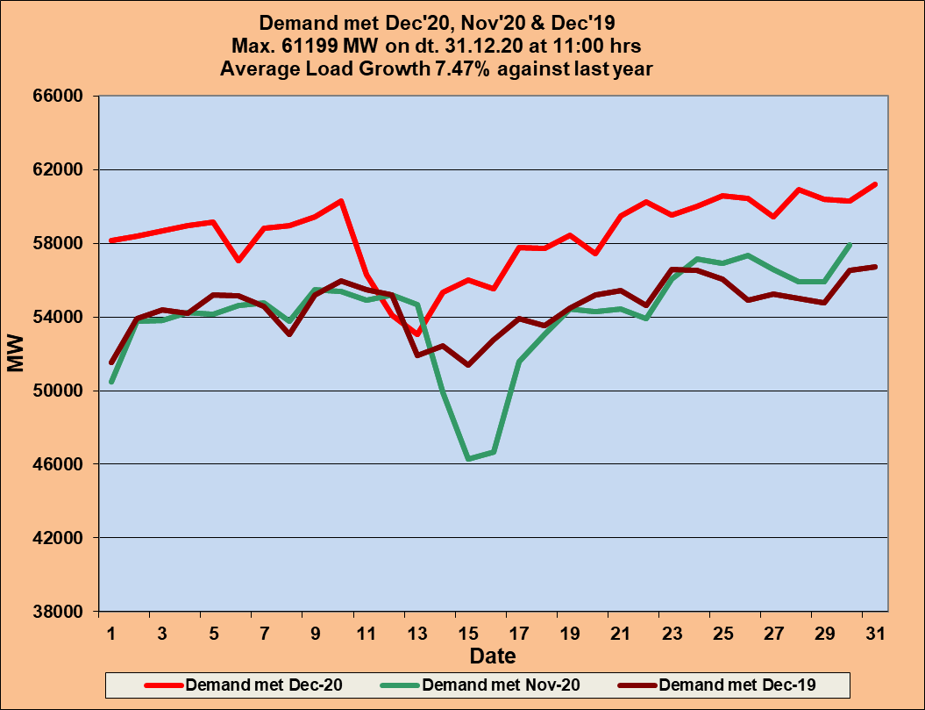

|  |  |  |  |  |  |
| --- | --- | --- | --- | --- | --- |
| **Demand Met** | **Dec-20** | **Nov-20** | **Dec-19** | **% Change w.r.t last month** | **% Change w.r.t last Year** |
| **Average** | **50269** | **48369** | **46774** | **3.93** | **7.47** |
| **Max** | **61199** | **57890** | **56739** | **5.72** | **7.86** |
| **Date when Max.** | **31-Dec-20** | **30-Nov-20** | **31-Dec-19** | **~** | **~** |

**1.5 Seasonal Variation**

**Day-wise Demand Plot-**

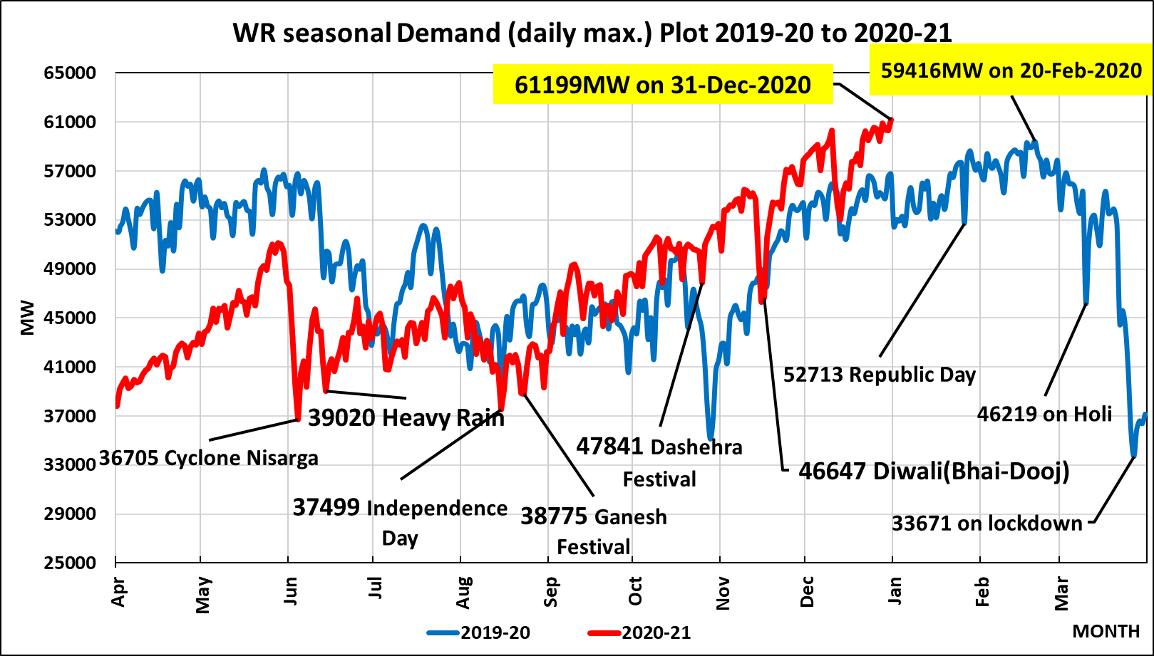

**Daily Energy Consumption**

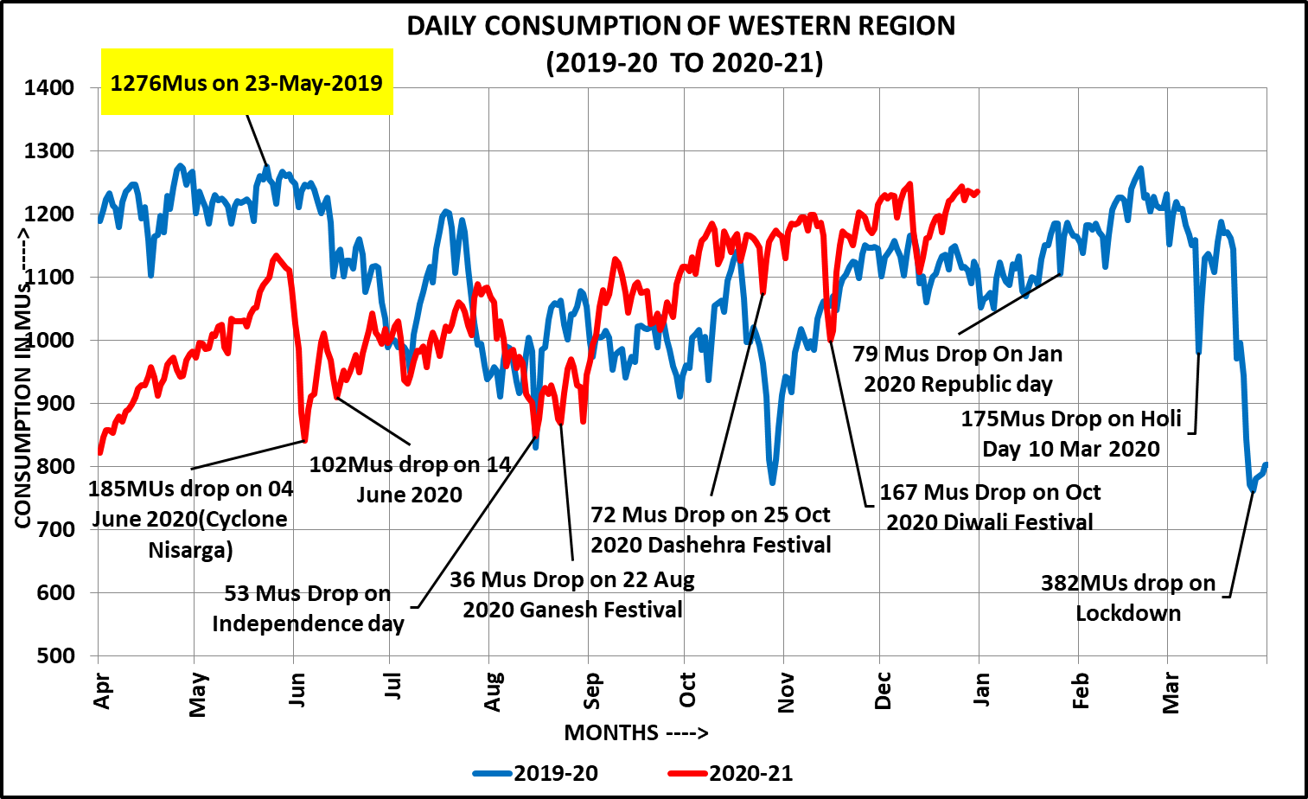

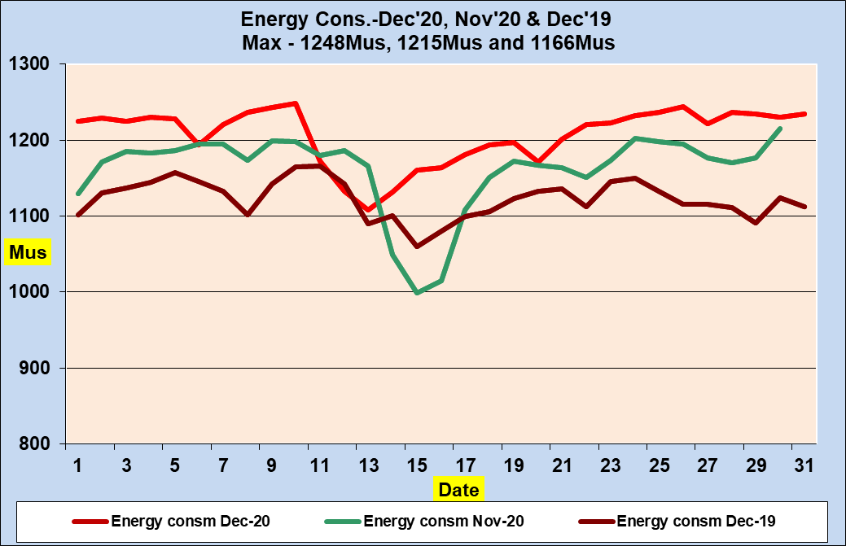

|  |  |  |  |  |  |
| --- | --- | --- | --- | --- | --- |
| **Energy Consumption MU/Day** | **Dec-20** | **Nov-20** | **Dec-19** | **% Change w.r.t last month** | **% Change w.r.t last Year** |
| **Average** | **1206** | **1161** | **1123** | **3.93** | **7.47** |
| **Max** | **1248** | **1215** | **1166** | **2.73** | **7.02** |
| **Date When Max.** | **10-Dec-20** | **30-Nov-20** | **11-Dec-19** | **~** | **~** |

**1.6 आवृति रूपरेखा Frequency Profile-**



**Monthly FDI of Dec.’2020: 0.24**

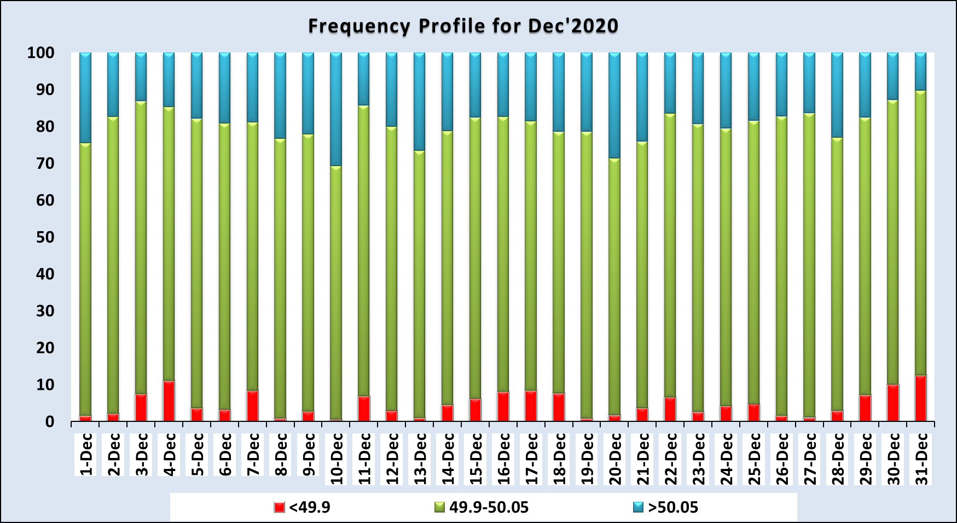

**1.7. विदयुत दाबरूपरेखा Voltage Profile-** **December’2020**







**1.8 नए एलेमेंट की वृद्धि Commissioning of New Elements**



**1.9 Schedule Vs Drawl of Western Region-Dec ’20**



**1.10 Generation Outages:**





**1.11 पश्चिमी क्षेत्र का जनरेशन Generation of Western Region Dec’2020**

**Renewables in WR- Wind Generation:**





|  |  |  |  |  |
| --- | --- | --- | --- | --- |
| **Highest ever Wind generation** | | | | |
| **State** | **Capacity**  **(in MW)** | **Generation**  **(in MW)** | **Date** | **Time** |
| **Gujarat** | **6324** | **4752** | **15.07.2019** | **19:00** |
| **Maharashtra** | **5000** | **3362** | **05.07.2019** | **10:00** |
| **MP** | **2520** | **1910** | **16.06.2018** | **08:00** |
| **Central** | **1718** | **1375** | **27.11.2020** | **01:00** |
| **WR** | **15562** | **9349** | **14.07.2019** | **13:00** |





**PLF/CUF for Wind Generation Constituent-wise:**



**Solar Generation:**



**अब तक का सबसे ज्यादा सौर उत्पादन 28.12.2020 को 4868 मेगावॉट 13:00 बजे.**

**So Far Highest Solar Generation on 28.12.2020 - 4868 MW at 13:00 hrs.**



|  |  |  |  |  |
| --- | --- | --- | --- | --- |
| **Highest ever Solar generation** | | | | |
| **State** | **Cap**  **(MW)** | **Gen**  **(in MW)** | **Date** | **Time** |
| **Gujarat** | **2772** | **1941** | **30.12.2020** | **13:00** |
| **Maharashtra** | **1632** | **1381** | **13.03.2020** | **12:00** |
| **MP** | **1630** | **1245** | **18.12.2020** | **12:00** |
| **Chhattisgarh** | **216** | **153** | **31.12.2018** | **12:00** |
| **Central** | **750** | **761** | **09.03.2020** | **13:00** |
| **WR** | **7000** | **4868** | **28-12-2020** | **13:00** |



**PLF for Solar Generation constituent-wise:**

**(Generating Hours taken: 12 hrs per day)**



**नेट लोड वक्र जब RES (पवन और सौर) उत्पादन अधिकतम था-**

**Net load Curve when RES (wind and Solar) Generation was max-**



**हाइड्रो जनरेशन व जलाशय स्तर मीटर में**

**Hydro Generation and Reservoir Level in Meter (Max in the Month)- FY 2020-21**

|  |  |  |  |  |  |  |  |
| --- | --- | --- | --- | --- | --- | --- | --- |
|  | **Madhya Pradesh** | | | **Gujarat** | | | **Maharashtra** |
| **Gandhi**  **Sagar** | **Indira sagar** | **Omkareshwer** | **Ukai** | **Kadana** | **SSP** | **Koyna** |
| **FRL-399.90 Mt MDDL –**  **381 Mt** | **FRL- 262.14 Mt MDDL –**  **243.24 Mt** | **FRL- 196.6 Mt MDDL –**  **193.5 Mt** | **FRL-105.16Mt MDDL –**  **82.30 Mt** | **FRL- 127.7 Mt MDDL –**  **114 Mt** | **FRL- 138.68 Mt MDDL –**  **110.64 Mt** | **FRL- 657.88 Mt MDDL –**  **609.60 Mt** |
| **April’20** | **397** | **255** | **196** | **101** | **122** | **122** | **647** |
| **May’20** | **395** | **254** | **196** | **99** | **122** | **121** | **641** |
| **June’20** | **395** | **252** | **196** | **97** | **120** | **127** | **635** |
| **July’20** | **395** | **250** | **194** | **99** | **120** | **121** | **642** |
| **Aug’20** | **397** | **261** | **195** | **102** | **127** | **131** | **658** |
| **Sep’20** | **398** | **262** | **195** | **104** | **127** | **138** | **659** |
| **Oct’20** | **399** | **262** | **196** | **105** | **127** | **135** | **659** |
| **Nov’20** | **399** | **262** | **196** | **104** | **127** | **135** | **659** |
| **Dec’20** | **398** | **261** | **196** | **104** | **127** | **134** | **658** |

































**1.12 पश्चिमी क्षेत्र का अंतरक्षेत्रीय आदान-प्रदान**

**Import = (+) , Export = (-)**

**Interregional Exchange of Western Region**









**1.13 आरआरएएस भुगतान विवरण RRAS PAYMENT DETAILS – From 30-11-2020 to 27-12-2020**





**1.14 REVISED AUFLS SETTING OF WR:**



**DF/DT Scheme**



**1.15 OPEN ACCESS TRANSACTION DETAILS**



**1.16 दिसम्बर 2020 में ग्रिड गड़बड़ी और ग्रिड की घटनाओं (GD/GI) की सूची: पश्चिमी क्षेत्र**

**List of Grid Disturbances and Grid incidents (GD/GI) in December 2020 : Western Region** 

**ANNEXURES**

**2.1 लोड अवधि वक्र Load Duration Curve**



**2.2 आवृत्ति अवधि वक्र Frequency Duration Curve**



**2.3** पीक और उच्चतम मांग दिन पर भार वक्र LOAD CURVE ON PEAK AND MAXIMUM DEMAND DAY





2.3 पीक और न्यूनतम मांग दिन पर भार वक्र LOAD CURVE ON PEAK AND MINIMUM DEMAND DAY





**2.4 UNITWISE INSTALLED CAPACITY November’2020**

|  |  |  |  |  |  |
| --- | --- | --- | --- | --- | --- |
| **Generating Station Details in Western Region** | | | | | |
| **CENTRAL SECTOR GENERATING STATIONS** | | | | | |
| **NTPC** | | | | | |
| **TYPE** | **STATION** | **INSTALLED CAPACITY** | | **EFFECTIVE CAPACITY** | |
| **UNITS** | **TOTAL (MW)** | **UNITS** | **TOTAL (MW)** |
| **Coal** | **KSTPS** | **3x200+3x500+1x500** | **2600** | **3x200+3x500+1x500** | **2600** |
| **VSTPS** | **6x210+2x500+2x500+3x500** | **4760** | **6x210+2x500+2x500+3x500** | **4760** |
| **Sipat STPS** | **2x500+3x660** | **2980** | **2X500+3X660** | **2980** |
| **Mauda** | **2x500+2x660** | **2320** | **2x500+2x660** | **2320** |
| **Solapur** | **2*660** | **1320** | **2*660** | **1320** |
| **Lara** | **2*800** | **1600** | **2*800** | **1600** |
| **Khargone** | **2*660** | **1320** | **2*660** | **1320** |
| **Gadarwara** | **2*800** | **1600** | **2*800** | **1600** |
| **NSPCL Bhilai TPP(*)** | **2x250** | **500** | **2x250** | **500** |
| **TOTAL Coal** | |  | **19000** |  | **19000** |
| **GAS** | **KAWAS** | **4x106+2x116** | **656.20** | **4x106+2x116.1** | **656.20** |
| **GANDHAR** | **3x144.3+1x224.49** | **657.39** | **3x144.3+1x224.49** | **657.39** |
| **TOTAL GAS** | |  | **1314** |  | **1314** |
| **GRAND TOTAL** | |  | **20314** |  | **20314** |
| **NPCIL** | | | | | |
| **TYPE** | **STATION** | **INSTALLED CAPACITY** | | **EFFECTIVE CAPACITY** | |
| **UNITS** | **TOTAL (MW)** | **UNITS** | **TOTAL (MW)** |
| **NUCLEAR** | **TAPS** | **2x160+2x540** | **1400** | **2x160+2x540** | **1400** |
| **KAPS** | **2x220** | **440** | **2x220** | **440** |
| **TOTAL NUCLEAR** | |  | **1840** |  | **1840** |
| **RES** | | | | | |
| **Solar** | **ACME** |  | **250** |  | **250** |
| **ARINSUN** |  | **250** |  | **250** |
| **Mahindra** |  | **250** |  | **250** |
| **Wind** | **OSTRO** |  | **250** |  | **250** |
| **ReNew Power Ltd** |  | **350** |  | **185** |
| **GIWEL II** |  | **250** |  | **250** |
| **GIWEL III** |  | **300** |  | **300** |
| **IWISL** |  | **500** |  | **200** |
| **AGEMPL(Wind)** |  | **725** |  | **176** |
| **Alfanar (Wind)** |  | **300** |  | **234** |
|  | **Renew(AP2)** |  | **300** |  | **95** |
| **Total** | | **Solar** | **750** |  | **750** |
| **Wind** | **2975** |  | **1690** |
| **CENTRAL SECTOR SUMMARY** | | | | | |
|
| **TOTAL CENTRAL SECTOR** | **Coal** |  | **19000** |  | **19000** |
| **GAS** |  | **1314** |  | **1314** |
| **NUCLEAR** |  | **1840** |  | **1840** |
| **RES** |  | **3725** |  | **2460** |
| **GRAND TOTAL (CENTRAL SECTOR)** | |  | **25879** |  | **24594** |
| **STATE SECTOR GENERATING STATIONS** | | | | | |
|
| **GUJARAT** | | | | | |
|
| **TYPE** | **STATION** | **INSTALLED CAPACITY** |  | **EFFECTIVE CAPACITY** |  |
| **UNITS** | **TOTAL (MW)** | **UNITS** | **TOTAL (MW)** |
| **HYDRO** | **UKAI** | **4x75** | **300** | **4x75** | **300** |
| **UKAI (LBCH)** | **2x2.5** | **5** | **2x2.5** | **5** |
| **KADANA** | **4x60** | **240** | **4x60** | **240** |
| **MADHUBAN DAM** | **2x1.5+2.6** | **5.6** | **2*1.5+2.6** | **5.6** |
| **KARJAN DAM** | **2x1.5** | **3** | **2x1.5** | **3** |
| **PANAM CANAL** | **2x1** | **2** | **2x1** | **2** |
| **Areva Hydro, Daulatpura** | **3x4** | **12** | **3x4** | **12** |
| **SARDAR SAROVAR** | **16% of 1450** | **1450** | **16% of 1450** | **232** |
| **TOTAL HYDRO** | |  | **2017.6** |  | **791** |
| **Coal** | **A.E.Co.(Torrent Power)** | **1x0+2x121+120** | **362** | **1x0+2x110+120** | **362** |
| **UKAI** | **2x0+2x200+1x210+ 1x500** | **1110** | **2x0+2x200+1x210+ 1x500** | **1110** |
| **GANDHI NAGAR** | **2x0+3x210** | **630** | **2x0+3x210** | **630** |
| **WANAKBORI** | **7x210** | **1470** | **7x210** | **1470** |
| **SIKKA** | **2x0+2x250** | **500** | **2x0+2x250** | **500** |
| **KUTCH LIGNITE** | **2x70+2x75** | **290** | **2x70+2x75** | **290** |
| **SURAT LIGNITE** | **4x125** | **500** | **4x125** | **500** |
| **AKRIMOTA** | **2x125** | **250** | **2x125** | **250** |
| **\*CGPL** | **\*\*3x830 +1x830+ 1x830** | **4150** | **\*\*3x830 +1x830+ 1x830** | **4150** |
| **\*Mundra(APL)** | **\*\*4*330 +2*660+3*660** | **4620** | **\*\*4*330 +2*660+3*660** | **4620** |
| **Essar Vadinar** | **2x600** | **1200** | **2x600** | **1200** |
| **BECL** | **2x250** | **500** | **2x250** | **500** |
| **OPGS** | **2x150** | **300** | **2x150** | **300** |
| **TOTAL Coal** | |  | **15882** |  | **15882** |
| **GAS** | **DHUVARAN** | **1x107+1x112+1x376** | **595** | **1x107+1x112+1x376** | **595** |
| **UTRAN-I** | **3x30+1x45** | **135** | **3x30+1x45** | **135** |
| **UTRAN-II** | **1X229+1X146(ST)** | **375** | **1X229+1X146(ST)** | **375** |
| **GIPCL I** | **3x32+49(ST)** | **145** | **3x32+49** | **145** |
| **GIPCL II** | **111+54(ST)** | **165** | **111+54** | **165** |
| **ESSAR\*\*** | **3x110+1x185 (ST)** | **215** | **3x110+1x185 (ST)** | **215** |
| **DGEN** | **3x400** | **1200** | **3x400** | **1200** |
| **Pipavav CCPP- GPCL & GSPC joint venture** | **2x351.43** | **702.86** | **2x351.43** | **702.86** |
| **GSEG Hazira I(Ext)** | **1x351** | **351** | **1x351** | **351** |
| **UNO Sugen** | **1x382.5** | **382.5** | **1x382.5** | **382.5** |
| **GSEG HAZIRA II** | **2x52+1x52.1 (ST)** | **156.1** | **2x52+1x52.1 (ST)** | **156.1** |
| **SUGEN** | **3X382.5** | **1147.5** | **3X382.5** | **1147.5** |
| **TOTAL GAS** | |  | **5570** |  | **5570** |
| **Diesel** |  |  | **0** |  | **0** |
| **RES** | **WIND+SOLAR+OTHERS** |  | **10996** |  | **10996** |
| **TOTAL GUJARAT** | **HYDRO** |  | **2017.6** |  | **791** |
| **COAL** |  | **15882** |  | **15882** |
| **GAS** |  | **5569.96** |  | **5569.96** |
| **GRAND TOTAL (GUJARAT)** | |  | **34466** |  | **33239** |
| **MADHYA PRADESH** | | | | | |
|
| **TYPE** | **STATION** | **INSTALLED CAPACITY** | | **EFFECTIVE CAPACITY** | |
| **UNITS** | **TOTAL (MW)** | **UNITS** | **TOTAL (MW)** |
| **HYDRO** | **GANDHI NAGAR** | **5x23 (50%)** | **115** | **5x23 (50%)** | **57.5** |
| **R P SAGAR** | **4x43 (50%)** | **172** | **4x43 (50%)** | **86** |
| **J SAGAR** | **3x33 (50%)** | **99** | **3x33 (50%)** | **49.5** |
| **PENCH SHARE** | **2x80 (66.67%)** | **160** | **2x80 (66.67%)** | **106.7** |
| **BANASAGAR TONS** | **3x105** | **315** | **3x105** | **315** |
| **BARGI** | **2x45** | **90** | **2x45** | **90** |
| **BANASAGAR** | **2x15+3x20+2x10** | **110** | **2x15+3x20+2x10** | **110** |
| **BIRSINGHPUR** | **1x20** | **20** | **1x20** | **20** |
| **RAJGHAT** | **3x15(50%)** | **45** | **3X15(50%)** | **22.5** |
| **INDIRA SAGAR** | **8x125** | **1000** | **8x125** | **1000** |
| **MADHIKHEDA HEP** | **3X20** | **60** | **3X20** | **60** |
| **MINI & MICRO HYDRO** | **5.46** | **5.46** | **5.46** | **5.46** |
| **Omkareswar Hydro** | **8x65** | **520** | **8x65** | **520** |
| **NVDA (BARGI LBC+ISP LBC)** | **2x5+3x5** | **25** | **2x5+3x5** | **25** |
| **RIHAND** | **6x50(15%)** | **300** | **6x50(15%)** | **45** |
| **MATATILA** | **3x10(15%)** | **30** | **3x10(15%)** | **10** |
| **TOTAL HYDRO** | |  | **3066** |  | **2523** |
| **Coal** | **AMARKANTAK** | **2X120+1X210** | **450** | **2X120+1X210** | **450** |
| **SATPURA-II** | **1x200+1x210** | **410** | **1x200+1x210** | **410** |
| **SATPURA-III & IV** | **2x210+2x250** | **920** | **2x210+2x250** | **920** |
| **S GANDHI TPS I & II** | **4x210** | **840** | **4x210** | **840** |
| **S GANDHI TPS III** | **1x500** | **500** | **1x500** | **500** |
| **Jaypee Bina** | **2x250 (70%)** | **500** | **2x250 (70%)** | **500** |
| **\*SASAN (Unit 1-6)** | **\*\*6x660 (37.5%)** | **3960** | **\*\*6x660** | **3960** |
| **Jayprakash Nigrie(IPP)** | **2x660 (37.5%)** | **1320** | **2x660 (37.5%)** | **1320** |
| **SSTP(Shri Singhaji Thermal Power Station)** | **4x600** | **2400** | **4x600** | **2400** |
| **BLA POWER** | **1x45(35%)** | **45** | **1x45(35%)** | **45** |
| **Jhabua Power ( Avanta)** | **2x600** | **1200** | **2x600** | **1200** |
| **M B Power** | **2x600 (35%)** | **1200** | **2x600 (35%)** | **1200** |
| **TOTAL THERMAL** | |  | **13745** |  | **13745** |
| **Diesel** |  |  | **0** |  | **0** |
| **RES** | **WIND+SOLAR+OTHERS** |  | **5051** |  | **5051** |
| **TOTAL MADHYA PRADESH** | **HYDRO** |  | **3066** |  | **2523** |
| **THERMAL** |  | **13745** |  | **13745** |
| **GRAND TOTAL (MADHYA PRADESH)** | |  | **21862** |  | **21319** |
| **CHHATISGARH** | | | | | |
| **TYPE** | **STATION** | **INSTALLED CAPACITY** | | **EFFECTIVE CAPACITY** | |
|  |  | **UNITS** | **TOTAL (MW)** | **UNITS** | **TOTAL (MW)** |
| **HYDRO** | **HASDEO BANGO** | **3x40** | **120** | **3x40** | **120** |
| **Gangrel** | **4x2.5** | **10** | **4x2.5** | **10** |
| **Korba West Mini Micro Hydel** | **2X.85** | **1.7** | **2X.85** | **1.7** |
| **Sikasar** | **2x3.5** | **7** | **2x3.5** | **7** |
| **TOTAL HYDRO** | |  | **138.7** |  | **138.7** |
| **Coal** | **KORBA (E)** | **4x50+2x120** | **440** | **4X50+2X120** | **440** |
| **KORBA (W)** | **4x210+1x500** | **1340** | **4x210+1x500** | **1340** |
| **KORBA (E) ext-I** | **2x250** | **500** | **2x250** | **500** |
| **Korba West Power Corp. Ltd. (IPP)** | **1x600** | **600** | **1x600** | **600** |
| **JINDAL Stage I,** | **4x250** | **1000** | **4x250** | **1000** |
| **JINDAL(JSPL TPP)unit3 DCPP(IPP)** | **4x135** | **540** | **4x135** | **540** |
| **LANCO-Amarkantak** | **2x300** | **600** | **2x300** | **600** |
| **SVPL TPP** | **1x63** | **63** | **1x63** | **63** |
| **Spectrum Coal Private Ltd.** | **2x50** | **100** | **2x50** | **100** |
| **ESSAR Mahan** | **2x600** | **1200** | **2x600** | **1200** |
| **GMR-Chhatisgarh Energy Ltd** | **2x685** | **1370** | **2x685** | **1370** |
| **ACBIL,IPP** | **2x135+2*30** | **330** | **2x135+2*30** | **330** |
| **KSK Mahanadi,IPP(Unit 1,2 and Unit 4)** | **3x600** | **1800** | **3x600** | **1800** |
| **DB Power,IPP** | **2x600** | **1200** | **2x600** | **1200** |
| **JPL Stage II,IPP** | **4x600** | **2400** | **4x600** | **2400** |
| **BALCO** | **4x300+4*67.5+4*135** | **2010** | **4x300+4*67.5+4*135** | **2010** |
| **RKM Powergrn ltd** | **4x360** | **1440** | **4x360** | **1440** |
| **Marwa TPS** | **1x500+1x500** | **1000** | **1x500+1x500** | **1000** |
| **Maruti Clean Coal Power Ltd** | **1x300** | **300** | **1x300** | **300** |
| **JP Nigri** | **2x660** | **1320** | **2x660** | **1320** |
| **TRN Energy** | **2x300** | **600** | **2x300** | **600** |
|  | **SKS** | **2x300** | **600** | **1x300** | **600** |
| **TOTAL THERMAL** | |  | **20753** |  | **20753** |
| **CHHATTISGARH TOTAL** | **HYDRO** |  | **138.7** |  | **138.7** |
| **THERMAL** |  | **20753** |  | **20753** |
| **Diesel** |  |  | **0** |  | **0** |
| **RES** | **WIND+SOLAR+OTHERS** |  | **552** |  | **552** |
| **GRAND TOTAL (CHHATISGARH)** | |  | **21444** |  | **21444** |
| **MAHARASHTRA** | | | | | |
| **TYPE** | **STATION** | **INSTALLED CAPACITY** | | **EFFECTIVE CAPACITY** | |
|  | **UNITS** | **TOTAL (MW)** | **UNITS** | **TOTAL (MW)** |
| **HYDRO** | **KOYNA I & II** | **4x(65+5)+4x(75+5)** | **600** | **4x(65+5)+4x(75+5)** | **600** |
| **KOYNA III** | **4x80** | **320** | **4x80** | **320** |
| **KOYNA DPH** | **2x20** | **40** | **2X18** | **36** |
| **KOYNA IV** | **4x250** | **1000** | **4x250** | **1000** |
| **KHOPOLI** | **3x24** | **72** | **3x24** | **72** |
| **BHIVPURI** | **3x24+2x1.5** | **75** | **3x24+2x1.5** | **75** |
| **BHIRA** | **6x25** | **150** | **6x25** | **150** |
| **BHIRA PSS** | **1x150** | **150** | **1x150** | **150** |
| **VAITHARNA** | **1x60** | **60** | **1x60** | **60** |
| **TILLARI** | **1x66** | **66** | **1x66** | **66** |
| **BHIRA T/R** | **2x40** | **80** | **2x40** | **80** |
| **GOM HYDRO** |  | **38** |  | **38** |
| **DADSON** | **1x44** | **44** | **1x44** | **44** |
| **GHATGHAR** | **2x125** | **250** | **2x125** | **250** |
| **TOTAL HYDRO** | |  | **2945** |  | **2941** |
|  | **CHANDRAPUR** | **2x0+2x210+3x500** | **1920** | **2x0+2x210+3x500** | **1920** |
| **Coal** | **CHANDRAPUR Extension** | **1x500+1x500** | **1000** | **1x500+1x500** | **1000** |
| **TROMBAY** | **1x500+1x250** | **750** | **1x500+1x250** | **750** |
| **KORADI** | **2x210** | **420** | **2x210** | **420** |
| **KORADI** | **3x660** | **1980** | **3x660** | **1980** |
| **NASIK** | **3x210** | **630** | **3x210** | **630** |
| **KHAPERKHEDA** | **4x210+1x500** | **1340** | **4x210 +1x500** | **1340** |
| **PARLI** | **2x0+1x0+2x210+2x250+1x250** | **1170** | **2x0+1x0+2x210+2x250+1x250** | **1170** |
| **BHUSAWAL** | **2x210+ 2x500** | **1420** | **2x210+ 2x500** | **1420** |
| **REL DAHANU** | **2x250** | **500** | **2x250** | **500** |
| **PARAS** | **2x250** | **500** | **2x250** | **500** |
| **JSW Ratnagiri(Jaigad)** | **4x300** | **1200** | **4x300** | **1200** |
| **Mihan TPP(Abhijit)** | **4x61.5** | **246** | **4x62.5** | **246** |
| **Wardha Warora Power Co Ltd.** | **4x135** | **540** | **4x135** | **540** |
| **Vidharbha Industry, Butibori** | **2x300** | **600** | **2x300** | **600** |
| **APML,Tiroda-Ph-I(400 kV)** | **3x660** | **1980** | **3x660** | **1980** |
| **APML,Tiroda-Ph-II( 765 kV)** | **2x660** | **1320** | **2x660** | **1320** |
| **IEPL (Ideal Energy Power Ltd, Belapur)** | **1x270** | **270** | **1x270** | **270** |
| **IBL (India Bulls Limited, Amravati) Ratan India** | **5x270** | **1350** | **5x270** | **1350** |
| **GMR Warora** | **2x300** | **600** | **2x300** | **600** |
| **Indrajeet** | **1x77** | **77** | **1x77** | **77** |
| **Indorama** | **1x49** | **49** | **1x49** | **49** |
| **Finolex, Ratnagiri** | **1x43** | **43** | **1x43** | **43** |
| **JSW Boisar, Vashi Circle** | **1x37.6** | **37.6** | **1x37.6** | **37.6** |
| **Uttam Galwa** | **1x60** | **60** | **1x60** | **60** |
| **Gupta Energy ltd** | **2x60** | **120** | **2x60** | **120** |
| **Topworth Urja** | **1x30** | **30** | **1x30** | **30** |
| **Ultratech Cement ltd.** | **1x46** | **46** | **1x46** | **46** |
| **Vayunandana Power ltd** | **1x10** | **10** | **1x10** | **10** |
| **Dhariwal-I& II (STU)** | **1x300** | **300** | **1x300** | **300** |
| **ISMT Ltd** | **40** | **40** | **40** | **40** |
| **Suryalakshmi Cotton & Mills Ltd** | **25** | **25** | **25** | **25** |
| **Grace Industries Ltd** | **33** | **33** | **33** | **33** |
| **Prithvi Ferro Alloys Pvt. Ltd** | **18** | **18** | **18** | **18** |
| **RCF, , Pen circle** | **30** | **30** | **30** | **30** |
| **BILT Power, Baramati ® circle** | **5** | **5** | **5** | **5** |
| **Reliance Patalganga** | **20** | **20** | **20** | **20** |
| **Sunflag , Bhandara Circle** | **15** | **15** | **15** | **15** |
| **BILT Power,Chandrapur circle** | **10** | **10** | **10** | **10** |
| **Gopani Chandrapur circle** | **12** | **12** | **12** | **12** |
| **ONGC, Vashi circle** | **59.6** | **59.6** | **59.6** | **59.6** |
| **IG Petro, Vashi circle** | **4.2** | **4.2** | **4.2** | **4.2** |
| **Technocraft Industries, Kalyan Circle** | **5** | **5** | **5** | **5** |
| **Ratan India Pvt Ltd.(Sinner)** | **1x270+1x270** | **540** | **1x270+1x270** | **540** |
| **RPL URJA YEOTMAL** |  | **10** |  | **10** |
| **Siddhabali Ispat, Chandrapur Circle** |  | **20** |  | **20** |
| **TOTAL COAL** | |  | **21355.4** |  | **21355.4** |
| **GAS** | **TROMBAY-7A & 7B** | **120+60** | **180** | **120+60** | **180** |
| **URAN (G)** | **4x108** | **432** | **4x108** | **432** |
| **URAN-DPH** | **2x120** | **240** | **2x120** | **240** |
| **RATNAGIRI PHASE - I** | **2x205+1x230** | **640** | **2x205+1x230** | **640** |
| **RATNAGIRI PHASE -II** | **2x213 + 237.54** | **663.54** | **2x213 + 237.54** | **663.54** |
| **RATNAGIRI PHASE- III** | **2x213 + 237.55** | **663.54** | **2x213 + 237.55** | **663.54** |
| **Pioneer Gas Pvt Ltd** | **1x126 + 1x262** | **388** | **1x126 + 1x262** | **388** |
| **TOTAL GAS** | |  | **3207** |  | **3207** |
| **Diesel** | **Diesel** |  | **0** |  | **0** |
| **RES** | **WIND+SOLAR+OTHERS** |  | **9766** |  | **9766** |
| **MAHARASHTRA** | **HYDRO** |  | **2945** |  | **2941** |
| **COAL** |  | **21355.4** |  | **21355.4** |
| **GAS** |  | **3207.08** |  | **3207.08** |
| **RES** |  | **9779** |  | **9779** |
| **GRAND TOTAL (MAHARASHTRA)** |  |  | **37286** |  | **37282** |
| **GOA** | | | | | |
| **TYPE** | **STATION** | **INSTALLED CAPACITY** | | **EFFECTIVE CAPACITY** | |
| **UNITS** | **TOTAL (MW)** | **UNITS** | **TOTAL (MW)** |
| **Diesel** |  |  | **0** |  | **0** |
| **RES** |  |  | **5.12** |  | **5.12** |
| **GAS** | **RELIANCE, SALGAONKAR** | **1x39.82+1x8.2** | **48.02** | **1x39.82+1x8.2** | **48.02** |
| **GRAND TOTAL (GOA)** | |  | **53** |  | **53** |

|  |  |  |  |
| --- | --- | --- | --- |
| **Units Decommissioned** | |  |  |
| **UNIT** | **CAPACITY (MW)** | | **Withdrawn from** |
| Paras -2 | 55 | | 16-11-2010 |
| Parli -1 | 20 | | 12-12-2010 |
| Parli -2 | 20 | | 12-11-2010 |
| Parli-3 | 210 | | 10-05-2016 |
| Parli-4 | 210 | | 30-11-2019 |
| Parli-5 | 210 | | 30-11-2019 |
| Bhusawal -1 | 50 | | 15-12-2010 |
| Bhusawal -2 | 210 | | 01-04-2017 |
| Koradi - 1 to 4(105 MW each) | 420 | | 01-08-2011 |
| Koradi-5 | 200 | | 02-03-2017 |
| Satpura Stage I(Unit 1) | 62.5 | | 01-07-2014 |
| Satpura Stage I(Unit 2) | 62.5 | | 12-05-2013 |
| Satpura Stage I(Unit 3) | 62.5 | | 10-01-2013 |
| Satpura Stage I(Unit 4) | 62.5 | | 12-05-2013 |
| Satpura Stage I(Unit 5) | 62.5 | | 02-01-2013 |
| Amarkantak unit 2&3 | 2x120 | | 2014 & 2015 |
| Torrent Power | 100 | | 04-01-2014 |
| Vandana Vidyut,IPP | 1x135 | | 01-05-2015 |
| Gandhinagar | 2x120 | | 03-09-2016 |
| Korba East-II Unit-1 to 4 | 4x50 | |  |
| Chandrapur | 2x210 | | 01-04-2016 |
| UTRAN-I | 3x30+1x45 | | 22-01-2017 |
| ESSAR** | 3x110+1x185 (ST)-215(PPA withdrawn) | | 29-05-2016 |
| Sikka(1& 2) | 2x120 | | 01-04-2017 |
| Ukai(1& 2) | 2x120 | | 01-04-2017 |
| A.E.Co.(Torrent Power) | 1x60 | | 02-04-2018 |
| GPEC | 3x138+1x241(ST) | |  |
| TROMBAY(Unit-6) | 500 | | 30-07-2019 |

|  |  |
| --- | --- |
|  |  |

**2.5 दिसम्बर 2020 के लिए कोणीय विभाजन उल्लंघन रिपोर्ट**

**Angular separation violation report for December 2020**



**2.6 *System Reliability Indices (ATC/TTC and VDI) Monthly Report 2020-21:***

Details of percentage of time ATC (Available Transfer Capability) violation, percentage of time (N-1) criteria violation and Voltage Deviation Index (VDI) are available at link given below-

<https://posoco.in/reports/system-reliability-indices/monthly-vdittcatc/monthly-vdi-ttc-atc-2020-21/>

**वितरण Distribution**

**1. मुख्य अभियंता(भा.प्रे.),गेटको, एसएलडीसी,गोत्री, एन.एच-8, वडोदरा 390014**

**2. मुख्य अभियंता(भा.प्रे.),मध्यप्रदेश एसएलडीसी,नयागांव,जबलपुर 482008**

**3. मुख्य अभियंता(भा.प्रे.),महाराष्ट्र एसएलडीसी ,पोस्ट बॉक्स 95, ठाणे-बेलापुररोड,**

**एरोली,नवी मुंबई 400708**

**4.मुख्य अभियंता(भा.प्रे.),छत्तिसगड एसएलडीसी ,डंगानिया, रायपुर 492010**

**5. मुख्य विदुयत अभियंता,गोवा एसएलडीसी,3 री मंजिल,पणजीम,गोवा.**

**6.महाप्रबंधक ट्रांसमीशन,न्युक्लियरपावर कारपोरेशन,विक्रम साराभाई भवन,अनूशक्ति नगर, मुंबई 400094**

**7.कार्यपालक निदेशक,एन.टी.पी.सी,2री मंजिल ,समृद्धि ट्रेड सेंटर,एम.आय.डी.सी.,मरोल,**

**अंधेरी(पूर्व),मुंबई 400093**

**8. कार्यपालक अभियंता, विदयुत भवन, 66 के.वी.रोड ,सचिवालय के पास, अमली, दादरा और नगर हवेली, सिलवासा**

**396230**

**9. मुख्य विदुयत अभियंता, दमण और दिव इलेक्ट्रिसिटि डिपार्टमेन्ट,66/11केवी काचीगाम सब स्टेशन, सोमनाथ-**

**काचीगाम रोड, काचीगाम, दमण-396210**

**10.सदस्य सचिव,प.क्षे.वि.समिती,एफ-3,एम.आय.डी.सी.,मरोल, अंधेरी(पूर्व), मुंबई 400093**

**11. कार्यपालक निदेशक, पावर ग्रिड, प्रा.प्र.-I,संप्रीति नगर नारी रिंग रोड,नागपुर 440026**

**12. कार्यपालक निदेशक, पावर ग्रिड, प्रा.प्र.-II, क्षेत्रीय मुख्यालय,प्लॉट संख्या 54,रिया-रेवती रिसोर्ट के.पास,अब्मे**

**विद्यालय के सामने,समा सावली रोड , बाडोदरा -390008 (गुजरात)**

**13. कार्यपालक निदेशक, एन.एल. डी.सी., पावर सिस्टम ऑपरेशन कारपोरेशन लिमिटेड,**

**बी. 9, कुतुब इंस्टुटीएसनल, एरिया कटवारिया सराय, नई दिल्ली 110016**

**14. कार्यपालक निदेशक, पावर सिस्टम ऑपरेशन कारपोरेशन लिमिटेड, एन.आर.एल.डी.सी.,**

**18 ए. एस. एस. मार्ग ,कटवारिया सराय, नई दिल्ली 110016**

**15. कार्यपालक निदेशक,पावर सिस्टम ऑपरेशन कारपोरेशन लिमिटेड, एन.ई.आर.एल.डी.सी., ड़ोंग टिथ लोवर**

**नानगर, लापालंग, शिलांग-793006(मेघालय)**

**16. कार्यपालक निदेशक, पावर सिस्टम ऑपरेशन कारपोरेशन लिमिटेड, ई.आर.एल.डी.सी,14 गोल्फ क्लब रोड,**

**टोलीगंज, कोलकाता-700033**

**17. कार्यपालक निदेशक, पावर सिस्टम ऑपरेशन कारपोरेशन लिमिटेड, एस.आर.एल.डी.सी, 29 रेस कोर्स क्रॉस**

**रोड, बेंगलूर- 560009**